Email Delivery with ORM Stack

Contents

1. Introduction 3
2. Workflow diagram to deploy the stack 3
3. Create stack for the Email Delivery “Default Domain” 4
4. Plan the Job 6
5. Apply the Job 8
6. Verify in the Console 9
7. Destroy the stack 10

Introduction

The Oracle Cloud Infrastructure Email Delivery service provides a fast and reliable managed solution for sending secured, high-volume marketing and transactional emails.
The Email Delivery service provides tools necessary to send application-generated email for mission-critical communications such as receipts, fraud detection alerts, identity verification, and password resets.
The platform is optimized for bulk or marketing and transactional email, and not for personal correspondence email.
Oracle Cloud Infrastructure's Email Deliverability team manages the platform using key deliverability metrics to ensure the best sending reputation possible for your emails.

Workflow diagram to deploy the stack
Below diagram shows how the Terraform Artifact are applied in the OCI. While creating a ORM stack, using terraform deliverables Init, Plan and Apply is the flow to provision the resource in the OCI. We can have the deliverables in any of below.
- GitLab/GitHub Repo
- Bitbucket
- Can be in folder/.zip in the local disk
- Object Storage Bucket
- Can be in compartment
- Oracle provided Template


Create stack for the Email Delivery “Default Domain”

Go to OCI Console Developer Services Resource Manager Stacks select the compartment Create Stack

My Configuration Folder Browse Select the “analytics” folder that contains the terraform Upload

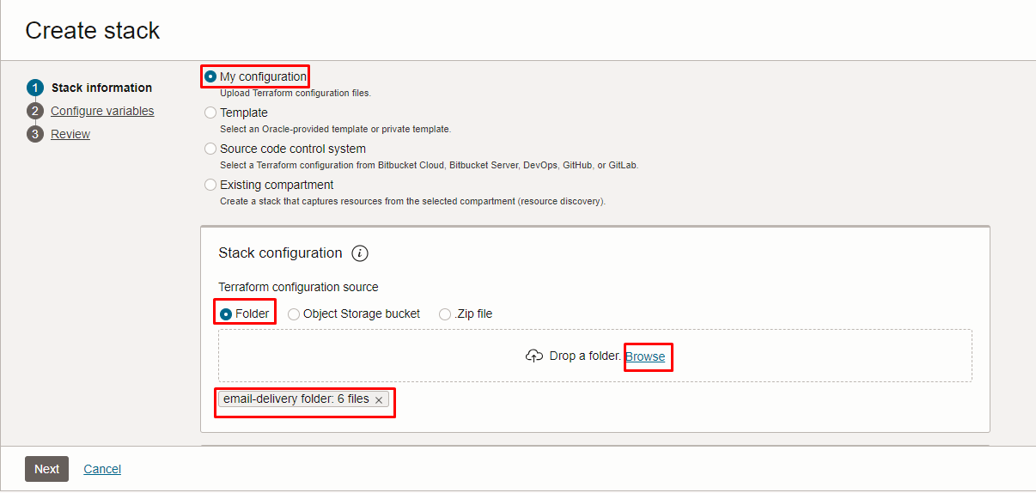
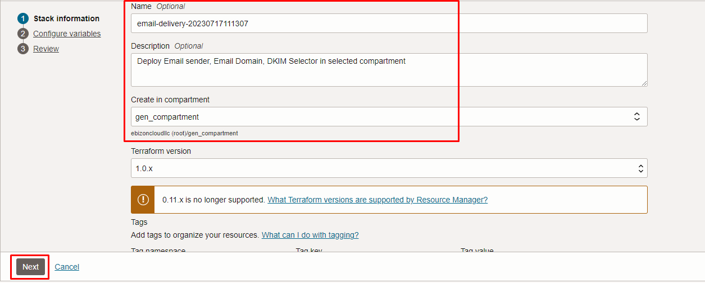

Click “NEXT”

Select the parameters as per the below screen,
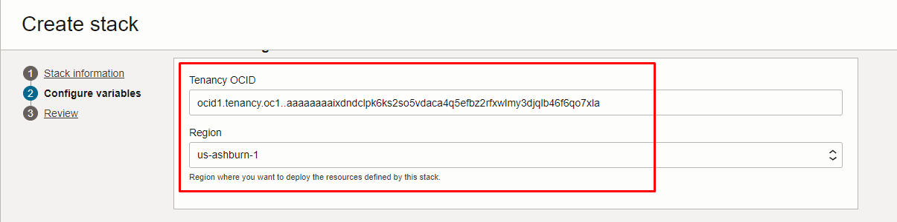
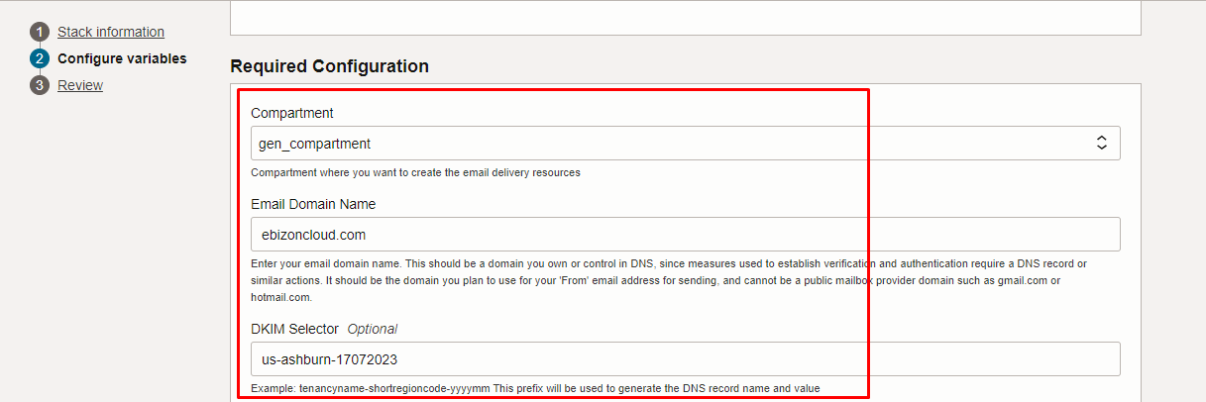
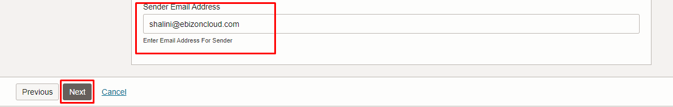

Click “NEXT” Click “CREATE”

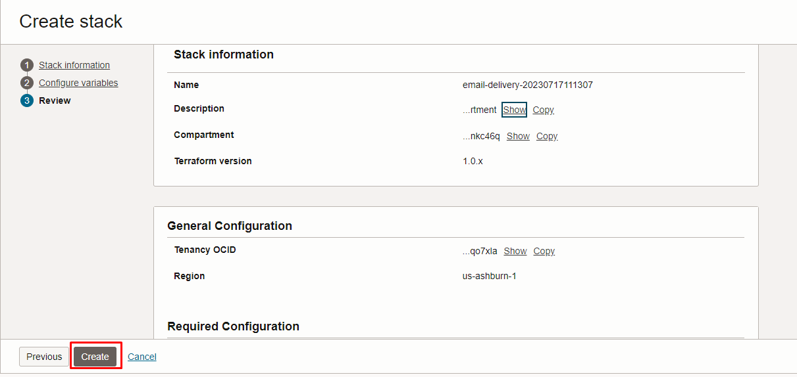

Plan the Job

Click the “Plan”

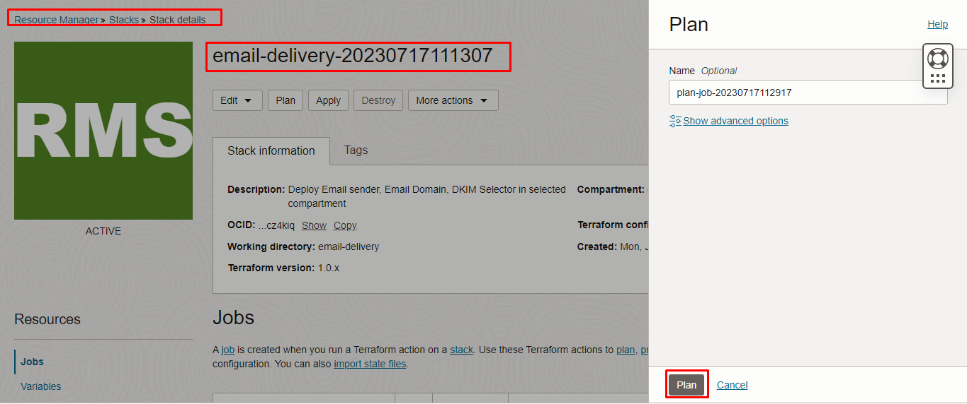

Verify the Plan is successful.

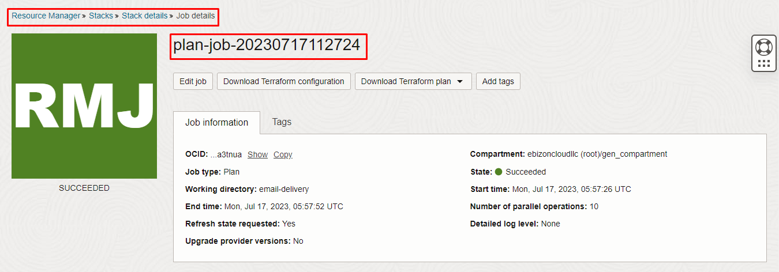

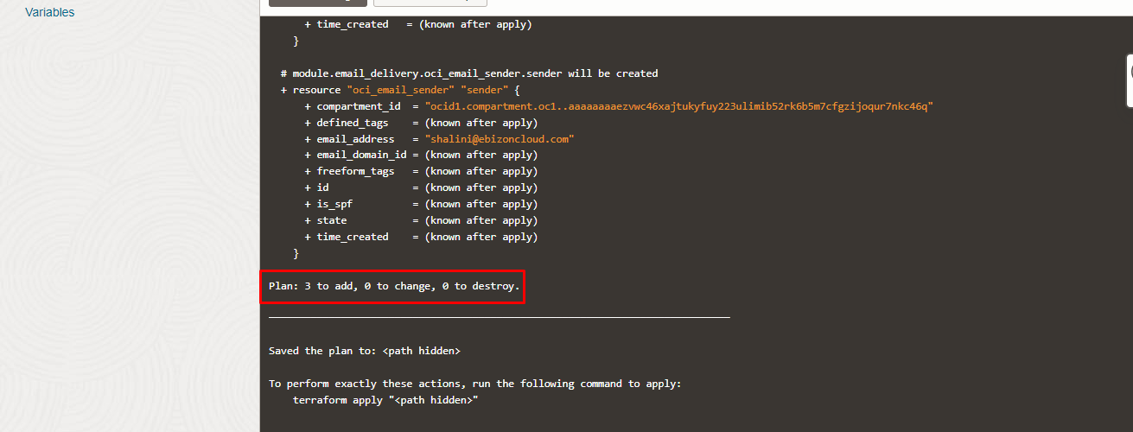

Apply the Job

Once the “plan” is success, now click “Apply”

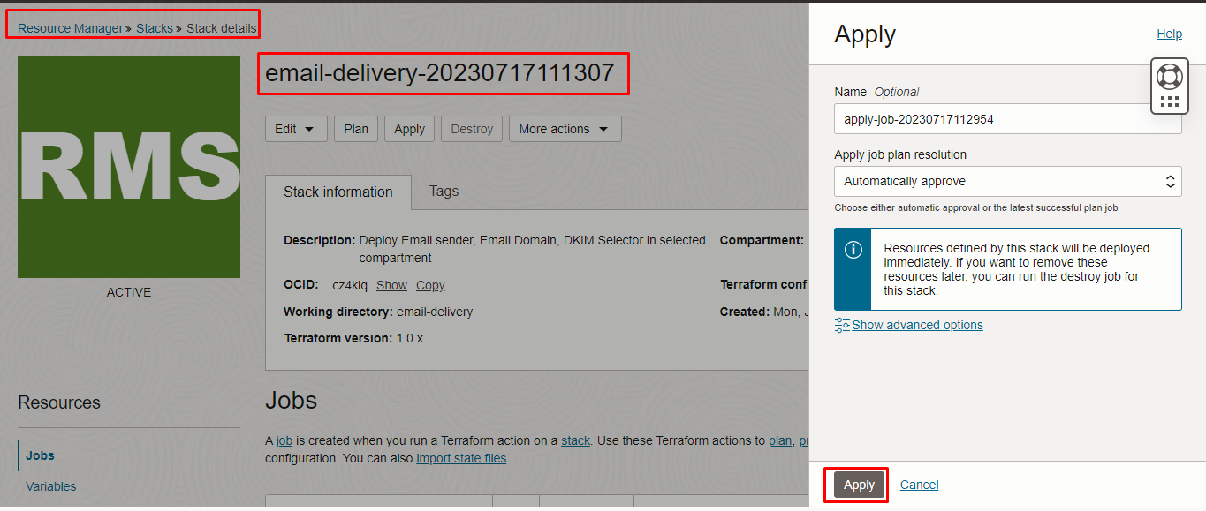
Verify the Apply is successful.

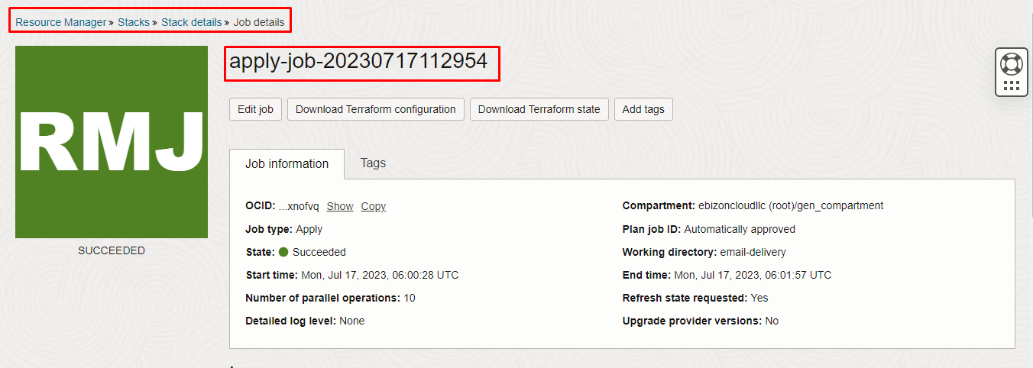

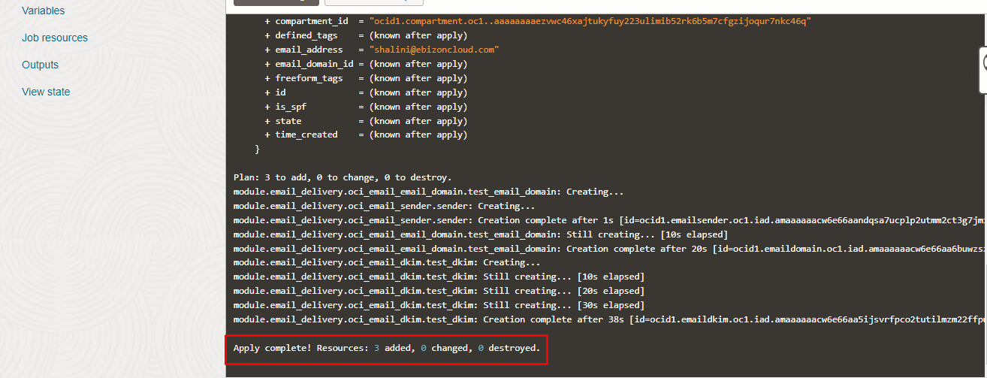

Verify in the Console

Go to OCI Console Developer Services Email Delivery
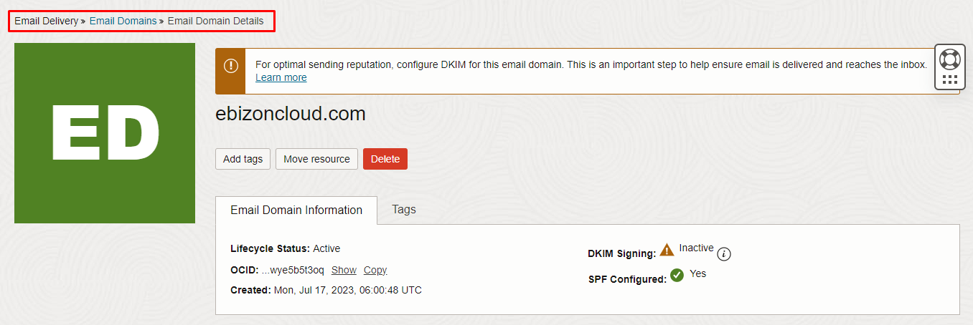
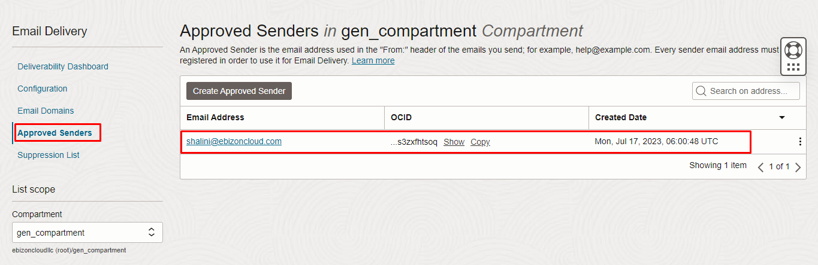

Destroy the stack

Create a destroy job in Resource Manager to release resources associated with a stack and clean up the tenancy. Once destroyed data cannot be recovered from resources.

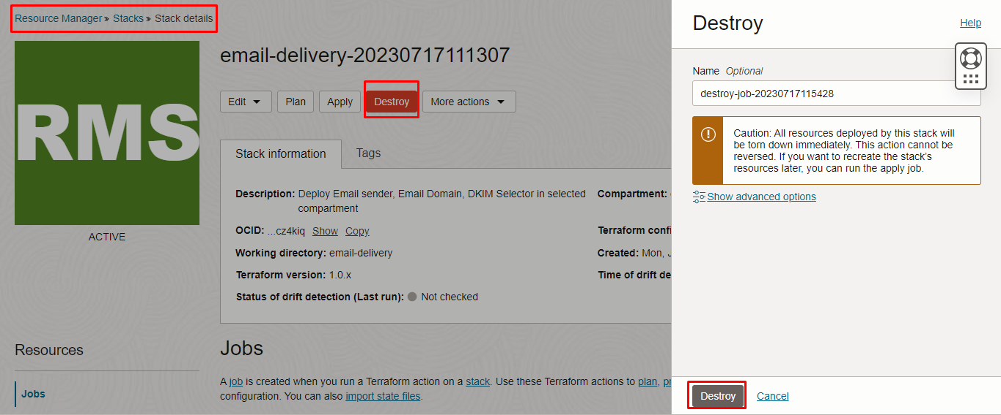

#####END#####

